# **Total Story Count Monte Carlo Forecast Exercise – Read First**

## Aim

To practice estimating the total number of stories (or story points) in a larger project by sampling just a few feature or epic story count breakdown examples. The goal is to get an estimate of total story count without having to analyze very feature or epic in a proposed project.

## Facilitation

1. Discuss with the group the goal “We are going to estimate how many stories (or points) in 10 features.”
2. Discuss the basic method “We are going to randomly build sets of 10 story counts and total how many stories are in each group of 10. We will do this for 11 trials, and these trials will allow us to understand the probability of each result. To save time, you just have to build the first two trials, the others are already done for you.”
3. Discuss what the samples are “We will be sampling actual story count examples performed by a team. The samples are counts of 36 prior features, but it could be far less, even as few as 7. You can prove this by crossing out some values in random samples and rolling again if you get one of those scrubbed out samples.”
4. Discuss how we learn probability “After we have built and totaled the 11 trials, we will count how many trials rounded down to the nearest ten value for simplicity. These counts will tell us how “probable” that many stories are likely. Likelihood is simply the ratio of how many trials are in a group divided by 11 (the number of trials). When done by spreadsheet we might do 1000 trials, but to save time we are just doing 11”

## Questions and discussion topics

1. **What could pollute the story count samples (make them a poor predictor of the future)?**
2. **Why can’t we just use the average or median values to forecast the story count in 10 features?**
3. **If life depended on this forecast, how many stories would you sign-up for?**
4. **How might you choose a likelihood to target in your company?**
5. **How would you get more definition in the likelihood percentages?**
6. **What does 100% likelihood mean in this case?**

## Why it works

If we sample at random the number of stories in features (or epics) analyzed by teams, then we can forecast the number of stories in any given number of features. The assumption is that the pattern in the samples is representative across the rest of the features not analyzed by the team. This will only be true if the features analyzed by the team are actually chosen truly at random. We help you do this here by rolling a two six-sided dice (or one six-sided dice twice). This technique build trials, actual possible sets of 10 features. Each one will be different, but the pattern in the results helps understand how likely each value is by its ratio across the whole set of trials. This is best done by spreadsheet, but this exercise is for learning.

## Resources

This exercise is for learning purposes, don’t do it by hand!

Download the “**Story Count Forecaster.xlsx**” spreadsheet from the spreadsheets folder at <http://Bit.Ly/SimResources>

# **Exercise – How Many Stories in 10 Features (or Epics)**

Aim: To estimate how many total stories there would be for 10 features (or epics). To understand the probability of achieving those story count estimated based on prior sampled history.

1. **Throw dice and record sample in the empty trial cells below using the sample sheet on the next page**

|  |  |  |  |  |  |  |  |  |  |  |
| --- | --- | --- | --- | --- | --- | --- | --- | --- | --- | --- |
| **Trial 1** | **Trial 2** | **Trial 3** | **Trial 4** | **Trial 5** | **Trial 6** | **Trial 7** | **Trial 8** | **Trial 9** | **Trial 10** | **Trial 11** |
|  |  | 2 | 12 | 3 | 12 | 3 | 1 | 3 | 1 | 6 |
|  |  | 5 | 15 | 3 | 5 | 10 | 10 | 2 | 6 | 3 |
|  |  | 4 | 4 | 3 | 20 | 3 | 3 | 2 | 3 | 2 |
|  |  | 3 | 2 | 2 | 2 | 3 | 3 | 3 | 4 | 6 |
|  |  | 8 | 6 | 1 | 6 | 6 | 3 | 1 | 2 | 4 |
|  |  | 8 | 10 | 8 | 3 | 1 | 2 | 1 | 3 | 12 |
|  |  | 1 | 2 | 1 | 3 | 1 | 2 | 5 | 1 | 3 |
|  |  | 1 | 1 | 4 | 5 | 3 | 10 | 1 | 1 | 10 |
|  |  | 15 | 12 | 3 | 3 | 6 | 6 | 4 | 15 | 12 |
|  |  | 6 | 3 | 1 | 8 | 2 | 1 | 6 | 20 | 3 |

1. **Sum each column above and enter the result in the cell below (use your phone calculator!)**

|  |  |  |  |  |  |  |  |  |  |  |
| --- | --- | --- | --- | --- | --- | --- | --- | --- | --- | --- |
|  |  | **53** | **67** | **29** | **67** | **38** | **41** | **28** | **56** | **61** |

1. **Round each sum above down to the nearest “ten” e.g. 10+, 20+, 30+, 40+, etc.**

|  |  |  |  |  |  |  |  |  |  |  |
| --- | --- | --- | --- | --- | --- | --- | --- | --- | --- | --- |
|  |  | **50+** | **60+** | **20+** | **60+** | **30+** | **40+** | **20+** | **50+** | **60+** |

1. **Compute the probabilities of achieving each result by counting the trials in each group**

This value is 0 to 1

Multiply it by 100 to get a percentage.   
0% = no chance, 100% means every trial achieved at least this level.

|  |  |  |
| --- | --- | --- |
| **Total Stories in 10 Features (or epics)** | **Count trial sum groups at least 30,40, 50, etc. stories** | **(Count / 11)**  **Likelihood** |
| At least **20** stories | 11 | 1 |
| At least **30** stories |  |  |
| At least **40** stories |  |  |
| At least **50** stories |  |  |
| At least **60** stories |  |  |
| At least **70** stories |  |  |
| At least **80** stories |  |  |
| At least **90** stories | 0 | 0 |

# **Samples: Random Samples of Epic to Story Count by Six-Sided Dice**

To generate random samples from the story count history, throw two six-sided dice (or throw one six-sided dice twice) and use the sample value at the intersection of the two dice results. It’s important to make certain samples are taken at random, and using a dice is often the fairest way to ensure you don’t introduce bias!

**First dice throw**

|  |  |  |  |  |  |  |
| --- | --- | --- | --- | --- | --- | --- |
|  |  |  |  |  |  |  |
|  | **2** | **5** | **1** | **3** | **8** | **4** |
|  | **10** | **2** | **20** | **3** | **4** | **1** |
|  | **2** | **12** | **15** | **5** | **2** | **1** |
|  | **3** | **1** | **10** | **2** | **3** | **1** |
|  | **3** | **3** | **8** | **4** | **3** | **1** |
|  | **6** | **3** | **3** | **6** | **4** | **2** |

These samples were from an actual project. The team selected 46 epics (features) at random out of 328 and broke them down into story level. They could have stopped at 10 an got the same answer

**Second dice throw**

# Total Story Count Forecasting using Spreadsheet

Download the “**Story Count Forecaster – exercise.xlsx**” spreadsheet from the spreadsheets folder at <http://Bit.Ly/SimResources> This spreadsheet has the feature story count sample data pre-loaded into the “Enter Features or Epics Here” worksheet.

Click on the “Forecast Story Count or Points” worksheet and enter the number of features you want to forecast, for example 10 as shown here –

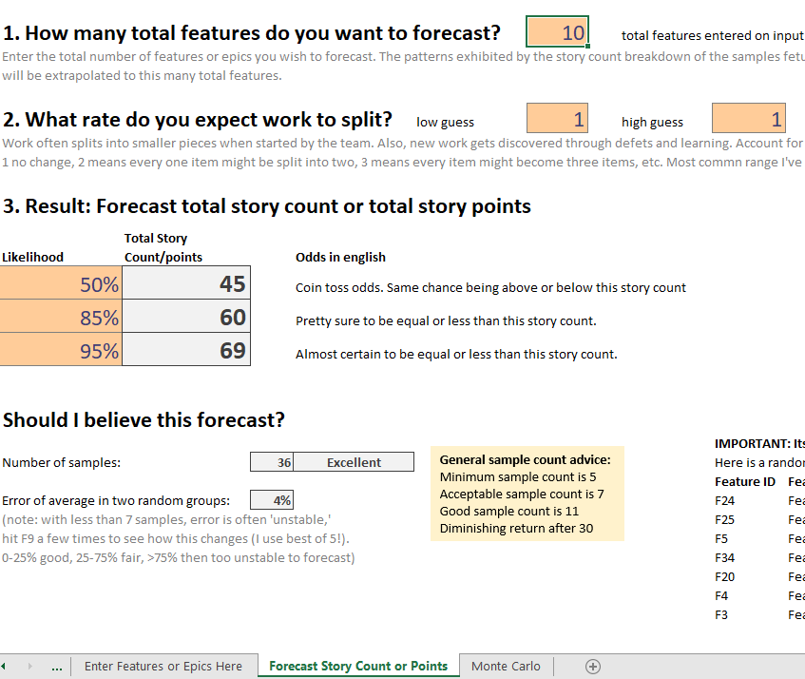

Exercises –.

1. The average of all story count samples is 4.6. That would be 46 total story count for 10 features. What probability is that equal to based on your analysis by-hand and spreadsheet?
2. Forecast total story count for 100 features.
3. Delete the estimated story count for all but 7 features. Did the forecast change much?

.